Diagnostic Medicare Center Management
Use Case Document


 | Prepared By / Last Updated By | Reviewed by | Approved By
Name | Shubham Srivastava | Shivam Goel | Ashu Jauhari
Role | Team Member | Team Member | Scrum Master
Signature | Shubham Srivastava | Shivam Goel | Ashu Jauhari
Date | 04/12/2019 | 04/15/2019 | 04/16/2019

Table of Contents
1.0 Introduction 4
1.1 Purpose & Scope of the document 4
1.2 Intended Audience 4
1.3 Use case ‘Customer Registration’ 4
1.3.1 Use case attributes 4
1.3.2 Business Rules 5
1.3.3 UI Requirements 5
1.3.4 UI Field Validations 5
1.4 Use case ‘Customer Credential Authentication’ 6
1.4.1 Use case attributes 6
1.4.2 Business Rules 7
1.4.3 UI Requirements 7
1.4.4 UI Field Validations 7
1.5 Use case ‘Doctor Registration’ 8
1.5.1 Use case attributes 8
1.5.2 Business Rules 8
1.5.3 UI Requirements 9
1.5.4 UI Field Validations 9
1.6 Use case ‘Doctor Credential Authentication’ 9
1.6.1 Use case attributes 9
1.6.2 Business Rules 10
1.6.3 UI Requirements 11
1.6.4 UI Field Validations 11
1.7 Use case ‘Admin Registration’ 11
1.7.1 Use case attributes 11
1.7.2 Business Rules 12
1.7.3 UI Requirements 12
1.7.4 UI Field Validations 13
1.8 Use case ‘Admin Credential Authentication’ 13
1.8.1 Use case attributes 13
1.8.2 Business Rules 14
1.8.3 UI Requirements 14
1.8.4 UI Field Validations 15
1.9 Use case ‘Update Medicare Service Details’ 15
1.9.1 Use case attributes 15
1.9.2 Business Rules 16
1.9.3 UI Requirements 16
1.9.4 UI Field Validations 17
1.10 Use case ‘View Medicare Service/Doctor Details’ 17
1.10.1 Use case attributes 17
1.10.2 Business Rules 17
1.10.3 UI Requirements 18
1.11 Use case ‘Raise Checkup Request’ 18
1.11.1 Use case attributes 18
1.11.2 Business Rules 19
1.11.3 UI Requirements 19
1.11.4 UI Field Validations 19
1.12 Use case ‘Update Test Results’ 20
1.12.1 Use case attributes 20
1.12.2 Business Rules 20
1.12.3 UI Requirements 21
1.12.4 UI Field Validations 21
1.13 Use case ‘View Test Results’ 21
1.13.1 Use case attributes 21
1.13.2 Business Rules 22
1.13.3 UI Requirements 22
1.14 Use case ‘Customer/Admin log off 23
1.14.1 Use case attributes 23
1.14.2 Business Rules 23
1.14.3 UI Requirements 24
2.0 Database Design 25
2.1 Tables Structure 25
3.0 Change Log 30

Introduction

Purpose & Scope of the document
The purpose of this Use case document is to systematically capture requirements for the project and the system to be developed in terms of use cases. Functional use cases are captured in this document. It also serves as the input for the project scoping.

The scope of this document is limited to addressing the use cases from a user, quality, and non-functional perspective.

Intended Audience
Each member of the project team

Use case ‘Customer Registration’

Use case attributes
Use Case Description:

This use case deals with Registration of the customer. The ‘Customer’ here shall be the operator of the system and will be keying in the Customer information into the system.

Scope:

- Customer registration

Actors:

- Customer – the operator

Trigger:

Click ‘Customer Registration’ option in the Home page.

Pre-Condition:

Customer being able to access the homepage & get redirected to the Customer Registration’ page upon click of ‘Customer Registration’ link.

Post Condition:

Customer is in the enrollment page & submit details.

Flow of Events:

Customer at homepage → Click ‘Customer Registration’ link → Customer is in the registration page → Customer details are submitted and added into the database

Primary Scenario:
A new Customer – is able to click ‘Customer Registration’ link and able to provide his details and get enrolled in the system.

Business Rules
Business rules should be defined using the following attributes: -

- When the customer clicks on the ‘Customer Registration’ link, it should re-direct to registration form.
    - User needs to fill some of the basic attributes/fields as mentioned below in requirement: First Name, Last Name, Age, Gender, Contact Number, Customer Id, Password and few more field based on the profile.
- Clicking ‘Submit’ should validate the datatype constraints for each field
- Post-successful field level validation, save the information in the database.
- Upon saving the information in the database, display the message ‘Your details are submitted successfully’.

UI Requirements
Here is a prototype on how the Customer Registration should look like.

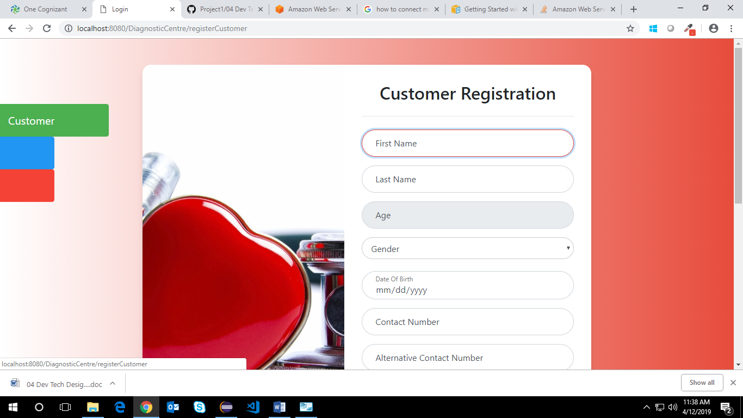
Figure 1.3.3 Customer Registration

UI Field Validations
Please refer to the below requirements for field level validations:

- All fields are mandatory.
- All ID of Customer should be Admin should be in the proper format. Password should have minimum 8 chars, no space & can contain special characters (ex.! @, #, %, *, & etc.)
- The Age of Customer should be greater than or equal to 18 years which would be calculated automatically else error message will be shown.
- The Email ID format must be checked. (For ex. test@testmail.com.)
- Phone Number must be of 10 digits’ length.

Use case ‘Customer Credential Authentication’

Use case attributes
Use Case Description:

This use case deals with the authentication of the customer credentials. The ‘customer’ here shall be the operator of the system and will be keying in the customer information into the system.

Scope:

- Customer credentials authentication

Actors:

Customer – the operator

Trigger:

Click ‘Login’ link, after keying in ‘Customer ID’ & ‘Password’ field.

Pre-Condition:

Customer being able to access the homepage

Post Condition:

Customer is in the Customer Details page

Flow of Events:

Customer at homepage → Key in ‘Customer ID’ & ‘Password’ field → Customer credentials are validated → Customer Details page is displayed

Primary Scenario:
A registered Customer – is able click ‘Login’ link, after keying in ‘Customer ID’ & ‘Password’ field and get his credentials authenticated with the existing database entry.

Alternative Scenario:
A registered Customer – is able click ‘Login’ link, after keying in ‘Customer ID’ & ‘Password’ field and unable to get his credentials authenticated. The Customer is presented with relevant error messages:

- Invalid Customer ID – ‘The Customer ID provided does not exist in our records’
- Incorrect Password – ‘Password provided is incorrect. Please reach out to your system admin.’

Business Rules
Business rules should be defined using the following attributes: -

- A registered customer – is able click ‘Login’ link, after keying in ‘Customer ID’ & ‘Password’ field and get his credentials authenticated with the existing database entry.

UI Requirements
Here is a prototype on how the Login Page should look like.

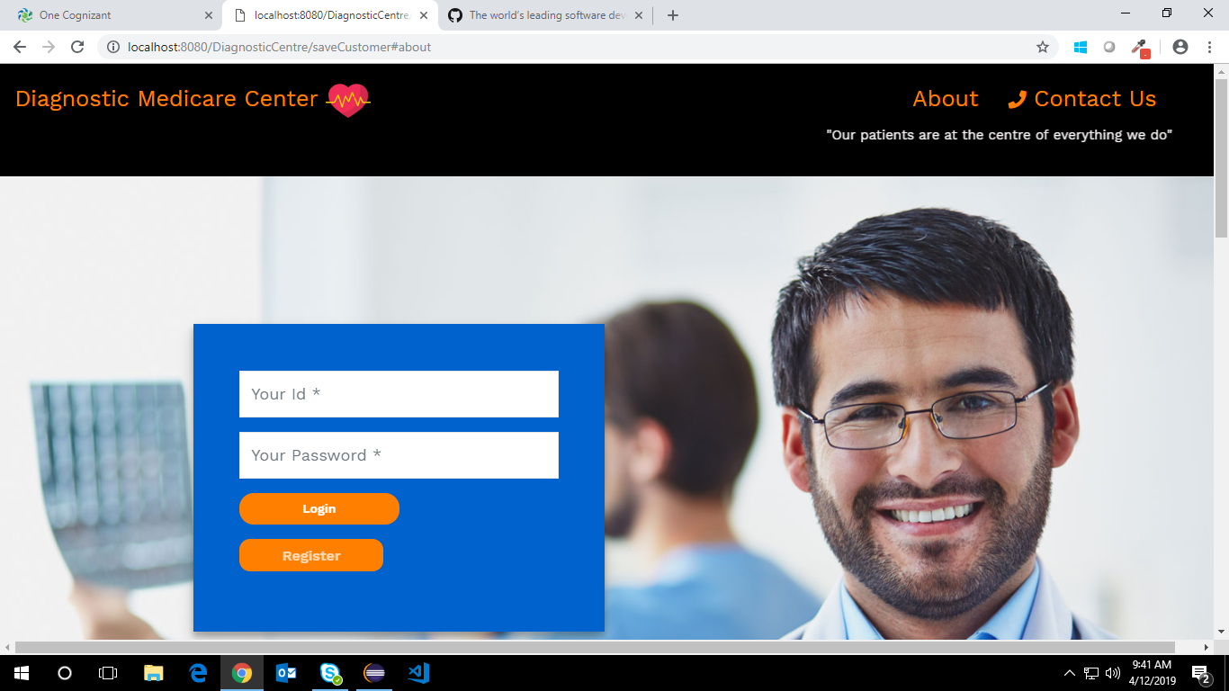
Figure 1.4.3 Customer Authentication

UI Field Validations
Please refer to the below requirements for field level validations:

- All fields are mandatory.
- All ID of Customer should be should be in the proper format.
- Password should have minimum 8 chars, no space and can contain special characters (ex.! @, #, %, *, & etc.)

Use case ‘Doctor Registration’

Use case attributes
Use Case Description:

This use case deals with Registration of the doctor. The ‘Doctor’ here shall be the operator of the system and will be keying in the Doctor information into the system.

Scope:

- Doctor registration

Actors:

- Doctor – the operator

Trigger:

Click ‘Doctor Registration’ option in the Home page.

Pre-Condition:

Doctor being able to access the homepage & get redirected to the Doctor Registration’ page upon click of ‘Doctor Registration’ link.

Post Condition:

Doctor is in the enrollment page & submit details.

Flow of Events:

Doctor at homepage → Click ‘Doctor Registration’ link → Doctor is in the registration page → Doctor details are submitted and added onto the database

Primary Scenario:
A new Doctor – is able to click ‘Doctor Registration’ link and able to provide his details and get enrolled in the system.

Business Rules

Business rules should be defined using the following attributes: -

- When the doctor clicks on the ‘Doctor Registration’ link, it should re-direct to registration form.
    - Doctor needs to fill some of the basic attributes/fields as mentioned below in requirement: First Name, Last Name, Age, Gender, Contact Number, Doctor Id, Password and few more field based on the profile.
- Clicking ‘Submit’ should validate the datatype constraints for each field
- Post-successful field level validation, save the information in the database.
- Upon saving the information in the database, display the message ‘Your details are submitted successfully’.

UI Requirements
Here is a prototype on how the Doctor registration should look like.

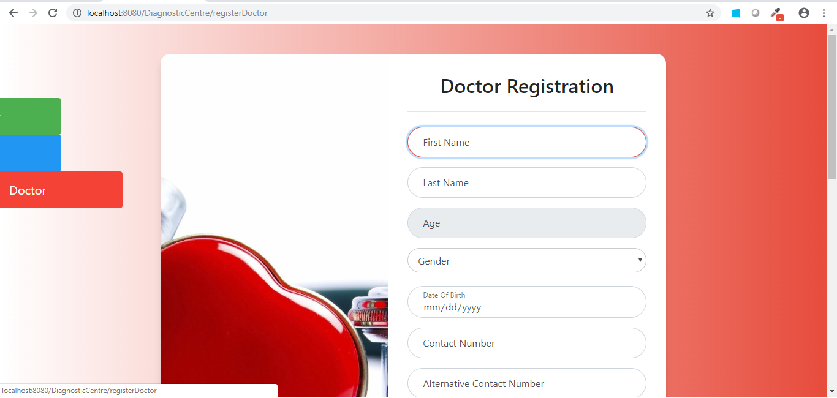
Figure 1.5.3 Doctor Registration

UI Field Validations
Please refer to the below requirements for field level validations:

- All fields are mandatory.
- All ID of Doctor should be should be in the proper format. Password should have minimum 8 chars, no space & can contain special characters (ex.! @, #, %, *, & etc.)
- The Age of Doctor should be greater than or equal to 18 years which would be calculated automatically else error message will be shown.
- The Email ID format must be checked. (For ex. test@testmail.com.)
- Phone Number must be of 10 digits’ length.

Use case ‘Doctor Credential Authentication’

Use case attributes
Use Case Description:

This use case deals with the authentication of the doctor credentials. The ‘doctor’ here shall be the operator of the system and will be keying in the doctor information into the system.

Scope:

- Doctor credentials authentication

Actors:

Doctor – the operator

Trigger:

Click ‘Login’ link, after keying in ‘Doctor ID’ & ‘Password’ field.

Pre-Condition:

Doctor being able to access the homepage

Post Condition:

Doctor is in the Doctor Dashboard

Flow of Events:

Doctor at homepage → Key in ‘Doctor ID’ & ‘Password’ field → Doctor credentials are validated → Doctor Dashboard is displayed

Primary Scenario:
A registered Doctor – is able click ‘Login’ link, after keying in ‘Doctor ID’ & ‘Password’ field and get his credentials authenticated with the existing database entry.

Alternative Scenario:
A registered Doctor – is able click ‘Login’ link, after keying in ‘Doctor ID’ & ‘Password’ field and unable to get his credentials authenticated. The Doctor is presented with relevant error messages:

- Invalid Doctor ID – ‘The Doctor ID provided does not exist in our records’
- Incorrect Password – ‘Password provided is incorrect. Please reach out to your system admin.’

Business Rules
Business rules should be defined using the following attributes: -

- A registered user – is able click ‘Login’ link, after keying in ‘Doctor ID’ & ‘Password’ field and get his credentials authenticated with the existing database entry.

UI Requirements
Here is a prototype on how the Doctor Login should look like.

Figure 1.6.3 Doctor Authentication

UI Field Validations
Please refer to the below requirements for field level validations:

- All fields are mandatory.
- All ID of Doctor should be in the proper format.
- Password should have minimum 8 chars, no space & can contain special characters (ex.! @, #, %, *, & etc.)

Use case ‘Admin Registration’

Use case attributes
Use Case Description:

This use case deals with Registration of the Admin. The ‘Admin’ here shall be the operator of the system and will be keying in the Admin information into the system.

Scope:

- Admin registration

Actors:

- Admin – the operator

Trigger:

Click ‘Admin Registration’ option in the Home page.

Pre-Condition:

Admin being able to access the homepage & get redirected to the Admin Registration’ page upon click of ‘Admin Registration’ link.

Post Condition:

Admin is in the enrollment page & submit details.

Flow of Events:

Admin at homepage → Click ‘Admin Registration’ link → Admin is in the registration page → Admin details are submitted and added onto the database

Primary Scenario:
A new Admin – is able to click ‘Admin Registration’ link and able to provide his details and get enrolled in the system.

Business Rules

Business rules should be defined using the following attributes: -

- When the admin clicks on the ‘Admin Registration’ link, it should re-direct to registration form.
    - Admin needs to fill some of the basic attributes/fields as mentioned below in requirement: First Name, Last Name, Age, Gender, Contact Number, Admin ID, Password and few more field based on the profile.
- Clicking ‘Submit’ should validate the datatype constraints for each field
- Post-successful field level validation, save the information in the database.
- Upon saving the information in the database, display the message ‘Your details are submitted successfully’.

UI Requirements
Here is a prototype on how the ‘Admin Registration’ should look like.

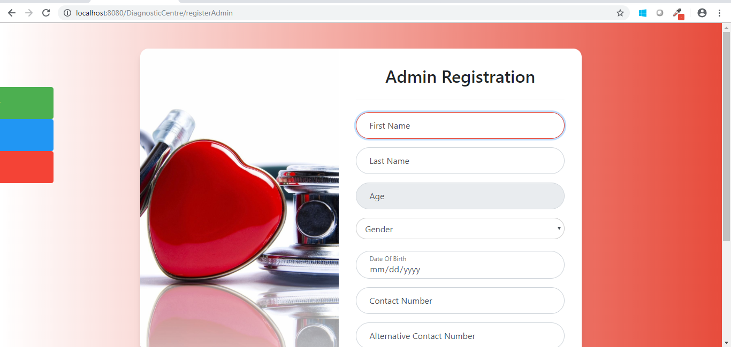
Figure 1.7.3 Admin Registration

UI Field Validations
Please refer to the below requirements for field level validations:

- All fields are mandatory.
- All ID of Admin should Admin should be in the proper format. Password should have minimum 8 chars, no space & can contain special characters (ex.! @, #, %, *, & etc.)
- The Age of Admin should be greater than or equal to 18 years which would be calculated automatically else error message will be shown.
- The Email ID format must be checked. (For ex. test@testmail.com.)
- Phone Number must be of 10 digits’ length.

Use case ‘Admin Credential Authentication’

Use case attributes
Use Case Description:

This use case deals with the authentication of the Admin credentials. The ‘Admin’ here shall be the operator of the system and will be keying in the Admin information into the system.

Scope:

- Admin credentials authentication

Actors:

Admin – the operator

Trigger:

Click ‘Login’ link, after keying in ‘Admin ID’ & ‘Password’ field.

Pre-Condition:

Admin being able to access the homepage

Post Condition:

Admin is in the Admin Dashboard

Flow of Events:

Admin at homepage → Key in ‘Admin ID’ & ‘Password’ field → Admin credentials are validated → Admin Dashboard is displayed

Primary Scenario:
A registered Admin – is able click ‘Login’ link, after keying in ‘Admin ID’ & ‘Password’ field and get his credentials authenticated with the existing database entry.

Alternative Scenario:
A registered Admin – is able click ‘Login’ link, after keying in ‘Admin ID’ & ‘Password’ field and unable to get his credentials authenticated. The Admin is presented with relevant error messages:

- Invalid Admin ID – ‘The Admin ID provided does not exist in our records’
- Incorrect Password – ‘Password provided is incorrect. Please reach out to your system admin.’

Business Rules
Business rules should be defined using the following attributes: -

- A registered Admin – is able click ‘Login’ link, after keying in ‘Admin ID’ & ‘Password’ field and get his credentials authenticated with the existing database entry.

UI Requirements
Here is a prototype on how the Admin Login should look like.

Figure 1.8.3 Admin Authentication

UI Field Validations
Please refer to the below requirements for field level validations:

- All fields are mandatory.
- All ID of Admin should be in the proper format.
- Password should have minimum 8 chars, no space & can contain special characters (ex.! @, #, %, *, & etc.)

Use case ‘Update Medicare Service Details’

Use case attributes
Use Case Description:

This use case deals with update Medicare service details. The ‘Doctor’ here shall be the operator of the system and will be keying in the information into the system.

Scope:

- Update Medicare service details

Actors:

- Doctor – the operator

Trigger:

Click ‘Update’ in Medicare Service page.

Pre-Condition:

Doctor being able to access the homepage & get redirected to the Doctor Details’ page upon click of ‘Doctor’ Login link and then redirect it to the Medicare Service Details page.

Post Condition:

Doctor is in the Medicare Service Details page in doctor dashboard and update details.

Flow of Events:

Doctor at homepage → Click ‘Doctor Login’ link → Doctor is in the doctor dashboard → Medicare Service Details are updated and added onto the database.

Primary Scenario:
Doctor – is able to click ‘Update’ in Medicare Service Details page and able to update the Medicare Service Details.

Business Rules

Business rules should be defined using the following attributes: -

- When the Doctor clicks on the ‘Update’ link, it should re-direct to form where the doctor can be able to update the Medicare Service details.
    - Doctor needs to update the data.
- Clicking ‘Update’ should validate the datatype constraints for each field
- Post-successful field level validation, save the information in the database.

UI Requirements
Here is a prototype on how the ‘Medicare Services Update details page should look like.

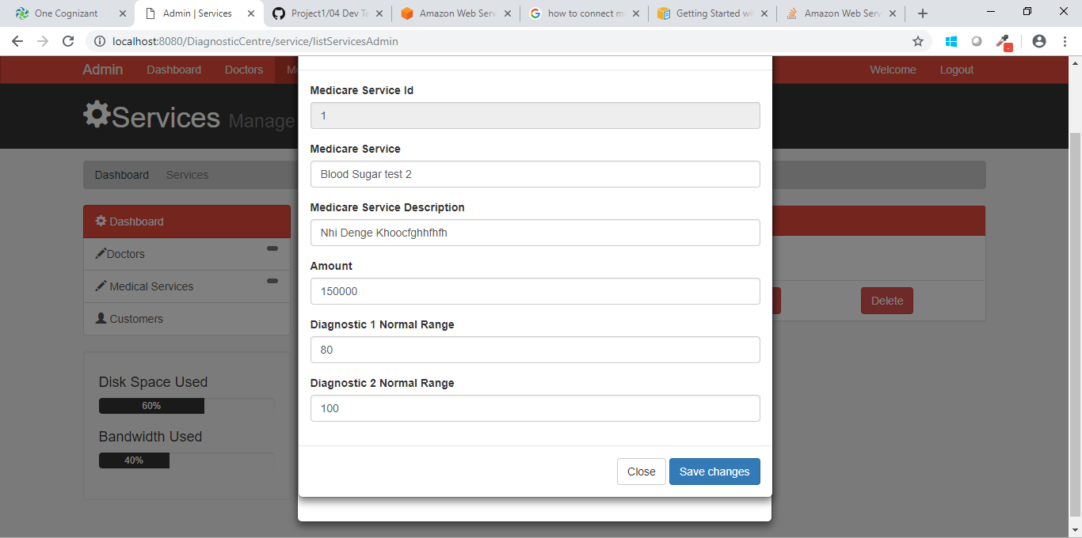
Figure 1.9.3 Update Medicare Service Details

UI Field Validations
Please refer to the below requirements for field level validations:

- The amount field should always be numeric.

Use case ‘View Medicare Service/Doctor Details’

Use case attributes
Use Case Description:

This use case deals with View of Medicare Service and doctor details.
The ‘Customer’ here shall be the operator of the system and will be able to view
Medicare Service and doctor details

Scope:

- View Medicare Service and doctor details

Actors:

- Customer – the operator

Trigger:

Click on ‘Medicare Service’ option in the Customer dashboard.

Pre-Condition:

Customer being able to access the Customer dashboard and get redirected to the ‘Medicare Service and doctor details’ page upon click of ‘Doctors/Medicare Service’ link.

Post Condition:

Customer should be able to view the doctors and Medicare services.

Flow of Events:

Customer at homepage → Click ‘Customer Login’ → Customer is in the customer dashboard → Customer will click on ‘Doctors/Medicare Service’ and then able to view the details.

Primary Scenario:
Customer – is able to click ‘Medicare services’ link and able to view the doctors and services details from the system.

Business Rules
Business rules should be defined using the following attributes: -

- When the Customer clicks on the ‘Medicare Service’ link, it should re-direct to Doctors/Medicare Service details page.
- Customer is now able to view the Doctors/Medicare Service details.

UI Requirements
Here is a prototype on how Doctors/Medicare Service details should look like.

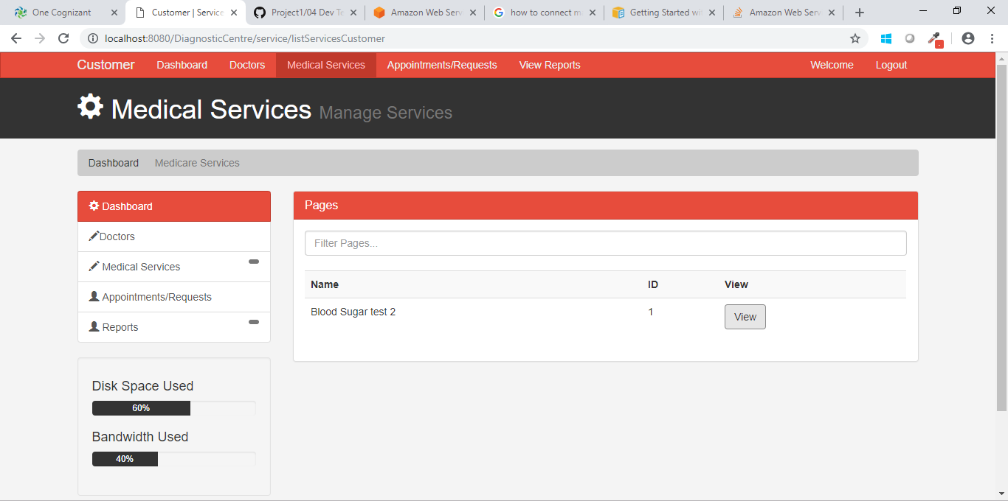
Figure 1.10.3 View Medicare Service/Doctor Details

Use case ‘Raise Checkup Request’

Use case attributes
Use Case Description:

This use case deals with raising the checkup request to the doctor. The ‘Customer’ here shall be the operator of the system and will be keying in the checkup request into the system.

Scope:

- Raise checkup request

Actors:

- Customer – the operator

Trigger:

Click ‘Request’ button, after keying in ‘Doctor ID’, ’Date’ and ‘Service Id’ field.

Pre-Condition:

Customer being able to access the Dashboard

Post Condition:

Customer is able to raise the request to the doctor

Flow of Events:

Customer at Login Page → Key in ‘Customer ID’ & ‘Password’ field → Customer credentials are validated →Customer Dashboard is displayed →Click on Request button.

Primary Scenario:
A registered customer – is able to click ‘Request’ button, after filling the required details the checkup request should be raised to the doctor.

Business Rules
Business rules should be defined using the following attributes: -

- A registered customer – is able click ‘Request’ button, after keying in required field it should be able to redirect the request to the doctor for the checkup.

UI Requirements
Here is a prototype on how the Raise Request by the Customer should look like.

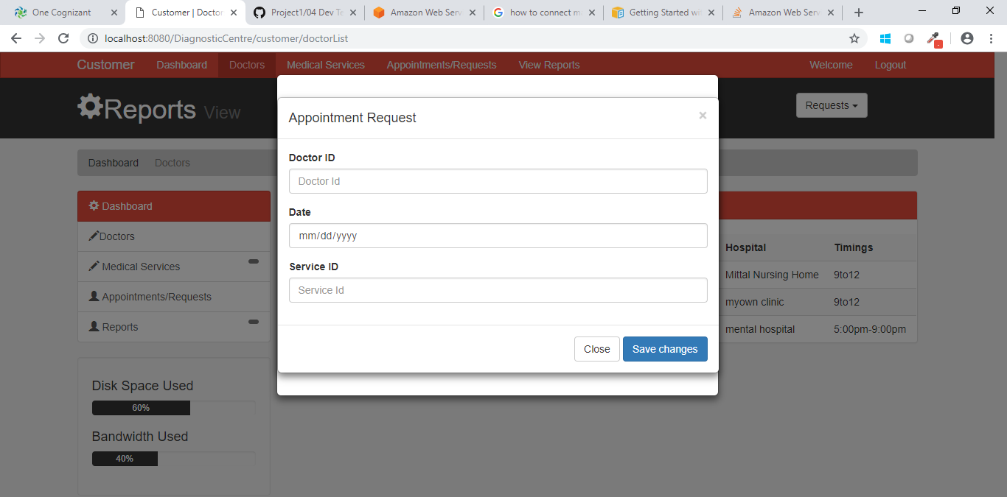
Figure 1.11.3 Raise Checkup Request

UI Field Validations
Please refer to the below requirements for field level validations:

- All fields are mandatory.
- Date Should be entered in the specified format

Use case ‘Update Test Results’

Use case attributes
Use Case Description:

This use case deals with the update of test result. The ‘Doctor’ here shall be the operator of the system and will be keying in the information into the Test result form.

Scope:

- Update Test Results

Actors:

- Doctor – the operator

Trigger:

Click ‘Update’ button in the appointment link of doctor dashboard.

Pre-Condition:

Doctor being able to Login and get redirected to the Doctor Dashboard. Click on ‘Update’ button in appointment link it will redirect to the desired form where doctor can update the test results.

Post Condition:

Doctor is able to submit the test result and customer can view it.

Flow of Events:

Doctor after Login → Click ‘Appointment’ link → Click on the desired customer update button → Test results gets stored into database.

Primary Scenario:
A Doctor – is able to click ‘update’ button for desired customer and able to update the test results.

Business Rules
Business rules should be defined using the following attributes: -

- When the doctor clicks on the ‘Login’ link, it should re-direct to doctor dashboard.
    - doctor needs to fill the form in the specified format.
- Clicking ‘Submit’ should validate the datatype constraints for each field
- Post-successful field level validation, save the information in the database.
- After saving the information in the database, now user can easily view the test results.

UI Requirements
Here is a prototype on how the ‘Update test result page’ should look like.

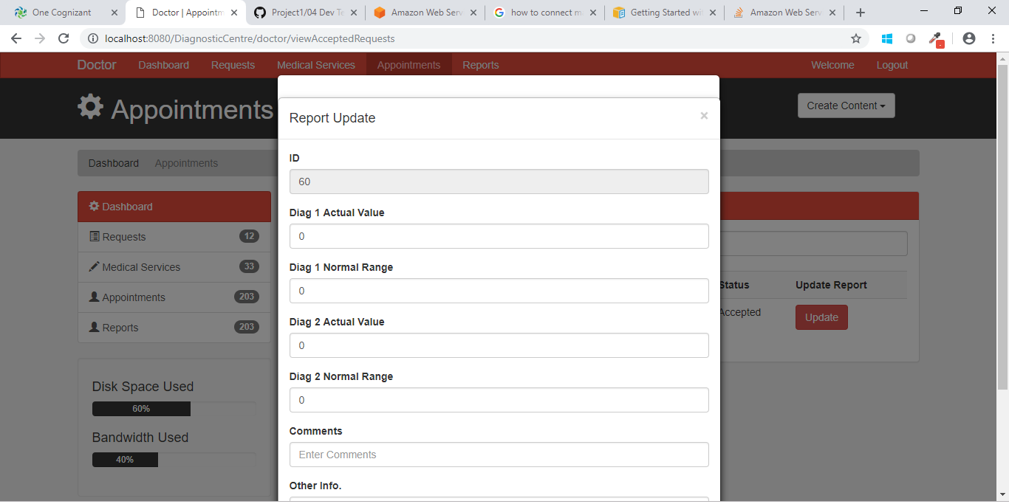
Figure 1.12.3 Update Test Results

UI Field Validations
Please refer to the below requirements for field level validations:

- All fields are mandatory.
- Enter the value in the numbers format for actual and normal
Range column.

Use case ‘View Test Results’

Use case attributes
Use Case Description:

This use case deals with the view of test result. The ‘Customer’ here shall be the operator of the system and will able to view the test result.

Scope:

- View Test Results

Actors:

- Customer – the operator

Trigger:

Click ‘View Reports’ link in the of customer dashboard.

Pre-Condition:

Customer being able to Login and get redirected to the Customer Dashboard. On click of ‘View reports’ link in customer dashboard it will redirect to the view page of results.

Post Condition:

Customer can view the test result.

Flow of Events:

Customer after Login → Click ‘View reports’ link → Now customer can easily view his/her test results.

Primary Scenario:
A Customer – is able to click ‘View reports’ link and then would be redirected to the view page of test results.

Business Rules
Business rules should be defined using the following attributes: -

- When the customer clicks on the ‘Login’ link, it should re-direct to customer dashboard.
- After following the above step now customer can view their test results that have been updated by the doctor.

UI Requirements
Here is a prototype on how the ‘View result page’ should look like.

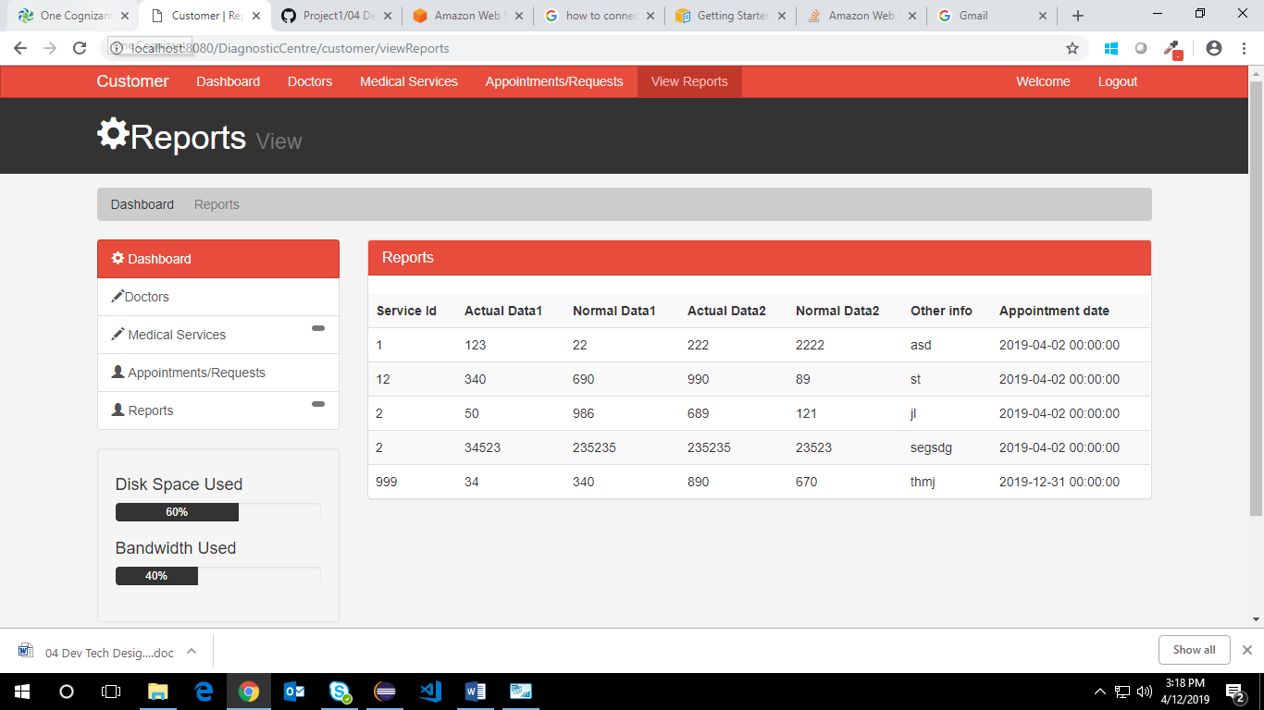
Figure 1.13.3 View Test Results

Use case ‘Customer/Admin log off’

Use case attributes
Use Case Description:

This use case deals with the log off functionality. The ‘Customer’ and ‘Admin’ here will be the operator of the system and will able to log off from their system when their task is completed.
Scope:

- Customer/admin log off.

Actors:

- Customer /admin– the operator

Trigger:

Click ‘logout’ link from the of customer dashboard or from the admin dashboard.

Pre-Condition:

Customer or admin being able to Login and get redirected to the Customer Dashboard or admin dashboard accordingly. On click of ‘Logout’ link in customer dashboard or in the admin dashboard the requested user gets logout from the system.

Post Condition:

Customer can view the test result.

Flow of Events:

Customer after Login → Click ‘Logout’ link → Now customer/admin can easily be able to logout from their system.

Primary Scenario:
Customer or admin being able to Login and get redirected to the Customer Dashboard or admin dashboard accordingly. On click of ‘Logout’ link in customer dashboard or in the admin dashboard the requested user gets logout from the system.

Business Rules
Business rules should be defined using the following attributes: -

- When the customer/admin clicks on the ‘Logout’ link, it should get logout from the system.

UI Requirements
Here is a prototype on how the ‘logout’ should look like.

Figure 1.14.3 Customer/Admin log off

Database Design

Tables Structure
Customer Registration:
Column Name | Data Type | Length | NULLS
Customer ID | Alphabetic | 10 | N
First Name | Alphabetic | 50 | N
Last Name | Alphabetic | 50 | N
Age | Numeric | 2 | N
Gender | Drop Down | NA | N
DoB | Alphanumeric | 10 | Y
Contact Number | Numeric | 10 | N
Email ID | Alphanumeric | 50 | N
Alt Contact Number | Numeric | 10 | Y
Password | Alphanumeric | 15 | N
Address Line 1 | Alphanumeric | 100 | N
Address Line 2 | Alphabetic | 100 | Y
City | Alphabetic | 50 | N
State | Alphabetic | 50 | N

Doctor Registration:
Column Name | Data Type | Length | NULLS
Doctor ID | Alphabetic | 10 | N
First Name | Alphabetic | 50 | N
Last Name | Alphabetic | 50 | N
Age | Numeric | 2 | N
Gender | Drop Down | NA | N
DoB | Alphanumeric | 10 | Y
Contact Number | Numeric | 10 | N
Alt Contact Number | Numeric | 10 | Y
Email ID | Alphanumeric | 50 | N
Password | Alphanumeric | 15 | N
Address Line 1 | Alphanumeric | 100 | N
Address Line 2 | Alphabetic | 100 | Y
City | Alphabetic | 50 | N
State | Alphabetic | 50 | N
Zip Code | Numeric | 10 | N
Degree | Alphabetic | 50 | N
Specialty | Alphabetic | 50 | N
Work hours | Drop down | NA | N
Hospital/Clinic Name | Alphanumeric | 100 | N
Medicare Service ID | Numeric | 10 | N

Admin Registration:
Column Name | Data Type | Length | NULLS
Admin ID | Alphabetic | 10 | N
First Name | Alphabetic | 50 | N
Last Name | Alphabetic | 50 | N
Age | Numeric | 2 | N
Gender | Drop Down | NA | N
DoB | Alphanumeric | 10 | Y
Contact Number | Numeric | 10 | N
Alt Contact Number | Numeric | 10 | Y
Email ID | Alphanumeric | 50 | N
Password | Alphanumeric | 15 | N

Medicare Services:
Column Name | Data Type | Length | NULLS
Medicare Service ID | Numeric | 10 | N
Medicare Service | Alphabetic | 50 | N
Service Description | Alphabetic | 200 | N
Amount | Numeric | 10 | N

Medical Test History:
Column Name | Data Type | Length | NULLS
Report ID | Numeric | 10 | N
Customer ID | Alphabetic | 10 | N
Doctor ID | Alphabetic | 10 | N
Medicare Service ID | Numeric | 10 | N
Agent ID | Alphabetic | 10 | N
Service date | Alphanumeric | 10 | N
Test Result date | Alphanumeric | 10 | N
Diag 1 – Actual Value | Numeric | 10 | N
Diag 1 – Normal Range | Numeric | 10 | N
Diag 2 – Actual Value | Numeric | 10 | Y
Diag 2– Normal Range | Numeric | 10 | Y
Diag 3 – Actual Value | Numeric | 10 | Y
Diag 3 – Normal Range | Numeric | 10 | Y
Diag 4 – Actual Value | Numeric | 10 | Y
Diag 4 – Normal Range | Numeric | 10 | Y
Diag 5 – Actual Value | Numeric | 10 | Y
Diag 5 – Normal Range | Numeric | 10 | Y
Diag 6 – Actual Value | Numeric | 10 | Y
Diag 6 – Normal Range | Numeric | 10 | Y
Doctors Comments | Alphabetic | 300 | N
Other info | Alphabetic | 300 | Y

Change Log
Version Number | Changes Made
V1.0 | N/A
Vx.y.z | N/A
Vx.y.z | Section No. | Changed By | Effective Date | Changes Effected
Vx.y.z | N/A | N/A | N/A | N/A

